Choose Your Own Inspector

A Custom Inspector Tool for Unity, from Imp Rock

Choose Your Own Inspector (CYOI) is a Unity tool that enables you to maintain a custom list of Editors for Components and assets, and keep them open while you work. From the Inspector, simply add an Editor to the list to keep it at hand for quick edits.

## The CYOI Window

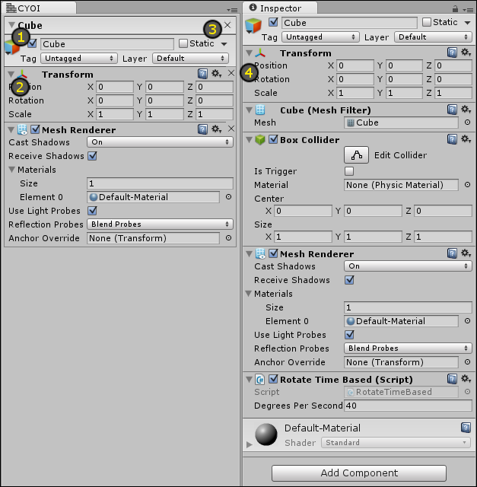

Refer to the image on the first page. On the left is the Choose Your Own Inspector window, shown here with Editors for the Transform and Mesh Renderer of some cube. The Inspector window shows all of the cube’s Editors on the right.

1. Editors sit within a Container, of which there are two types. Containers for GameObjects can hold multiple Editors for attached components. The name shown will be the name of the GameObject. The other type of container holds a single Asset Importer Inspector, which will be for assets within your project. Container title bars are collapsible via the foldout on the left side.
2. Component Editors are also collapsible within their Container, much like the Inspector.
3. Clicking the X button found on the right of the Container title bar will close all Editors within that Container.
4. Clicking the X button of any individual Editor will close that Editor, and if it is the only Editor within the Container, the Container will also close.

CYOI places no limit on the number of Containers or Editors you can add.

## Add Editors to CYOI

|  |  |
| --- | --- |
| C:\Users\dean\AppData\Local\Microsoft\Windows\INetCache\Content.Word\cyoi10_addtocyoi01.png  C:\Users\dean\AppData\Local\Microsoft\Windows\INetCache\Content.Word\cyoi10_addtocyoi02.png | Editors are added from the Inspector window. Some Editors will have a little gear icon in the top-right corner. Clicking this will bring up a menu with some options for that Editor.  Other Editors do not have this icon, so, to bring up the menu, you can context-click the Editor’s header (usually its name is safe).  However you bring up this menu, you’ll find an option called *Add to CYOI*. Selecting this will add that editor to CYOI.  **Add as many as you like to Choose Your Own Inspector!** |

With the desired Editors added to CYOI, you can now select other objects or assets without losing your place.

## Remove Editors from CYOI

As mentioned before, you can click the X button in the upper-right of an Editor to close it. The X button found in the Container title bar will close all Editors within.

## Where CYOI Lives

|  |  |
| --- | --- |
| C:\Users\dean\AppData\Local\Microsoft\Windows\INetCache\Content.Word\cyoi10_installationfolder.png | Within the ImpRock folder is a subfolder for CYOI. This is where it lives. If you prefer, it can safely be moved to another folder in your project (as long as the folder is named “Editor”). Just know that if the DLL is moved, any future updates to CYOI may not install properly. |

## Known Issues

There are cases where an Editor uses animations, and those can be tricky to support in some cases. However, CYOI does its best to try to figure out if an Editor is animated so that it can repaint properly.

Notice that in the image on the first page, the Mesh Renderer Editor is indented differently in CYOI than it is in the Inspector. I have no idea why.

No preview windows! I’d like to add support for that at some point in the future. Maybe if this tool becomes popular enough, I’ll focus on it. Or, if I’m very curious one day, I’ll take a look.